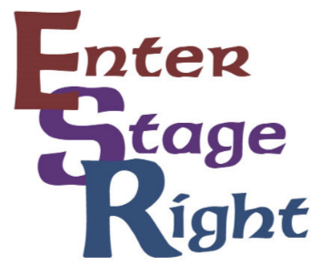
So you think you want to put on a production…..

It’s a fairly simple 3 step process. When ESR evaluates and approves a proposal the company is essentially giving a grant to the team wanting to put on the production. Enter Stage Right typically spends $5,000 to $8,000 on a given monthly production.
We’re proud to have the resources to put faith in teams of ESR artists bringing together their vision. With that in mind we do require a certain amount of experience in the director and producer roles.
Don’t have experience but still want to put on a show? No worries! We can pair you up with a current team and get you that experience so you can lead a show in the future!
If you have any questions, please feel free to call ESR’s Executive Director, Regina Spain @ 810-334-6415. She’ll be glad to walk you through the process and give advice on how to make your dream a reality!

